Part 1 — Unboxing Publisher · Publisher teardown
Publisher teardown · Part 1 of 2 · Packages and Question mode

Unboxing Publisher, from two packages I already knew
I rebuilt two of my existing data products as Publisher packages, used them to find out where the product works and where it snags, and added a new way to ask a question in the explorer.
Noah · product + design engineering update · draft, Sep 30, 2026
Built with Opus 5.5 · screenshots from Publisher on :4000 and the dev Console on :5173, on main plus uncommitted work
TL;DR
- Two new example packages, questionable-football and signals-research, rebuild data.questionablefootball.com and stocks.getobjective.app on Publisher. Every number is defined in Malloy, not in an export script or in app code.
- Every surface is used for real: hand-written HTML data apps, no-code dashboards, a notebook, and saved findings that re-run live. Together that is about 3,000 lines of Malloy and 6,300 lines of HTML, JS and CSS, with no build step.
- Question mode is a second way to build a query in the model explorer. You answer three questions (measure, group by, segment by), and any combination of answers draws a valid chart. Switching to the Fields builder and back keeps the query.
- The teardown: the model, the governed query path and the agent workflow held up. The friction was in the first ten minutes (connecting MCP, reloading, stale models) and in the explorer, which assumes you already think in Malloy.
- Part 2 follows these packages into the destination, the reader-facing app where their content becomes a workspace Library.

01 Unboxing
What comes in the box, and what a new person, or a new agent, meets in the first hour.
Publisher serves Malloy packages over REST and one MCP endpoint, and puts a Console in front of them. A package is a directory: publisher.json, some .malloy models, data or a connection, and optionally a public/ folder of pages. From that one directory you get five surfaces, all on the same governed query path:
Surface | What it is | Who it's for
Model | Sources, dimensions, measures and views in .malloy files | Whoever owns the definitions
Explorer | Build a query against a source in the Console | Analysts, and now the curious (§06)
Dashboard | A tagged dashboards/*.malloy file: filters, grid layout, drill-through | Operators who want filters and no code
Notebook | A .malloynb file that mixes prose and queries | A walk through one argument
Data app | Hand-written HTML in public/ calling Publisher.query | A product with a point of view

The first hour
The AGENTS.md fast path is four steps: start the server, connect MCP, list_packages, then get_context and execute_query. When it works, an agent with no prior knowledge goes from "what's here?" to a grounded answer in three tool calls. Where it doesn't work, the failures look alike from the outside:
- MCP tools missing. There are three causes: the client connected before the server existed, the session started in the wrong directory, or no .mcp.json was written. They have three different fixes. AGENTS.md spends a whole table on telling them apart, and that table exists because people kept hitting all three.
- An edit that doesn't show up. A model change is not queryable until the package reloads, and a reload that fails to compile keeps serving the old model. The stale: true flag in loadErrors is the only signal. For a human, "the number didn't change" is the whole symptom.
- Which copy am I editing? Outside watch mode, the server reads a copy under publisher_data/, not the directory you're editing.
Editor: Add my own first-hour notes here: what I expected, what surprised me, and the time to a first chart.

02 Prior art
Both packages started from products I had already built and had data access for, so the design question was never "what should this show?" It was "can Publisher carry it?"
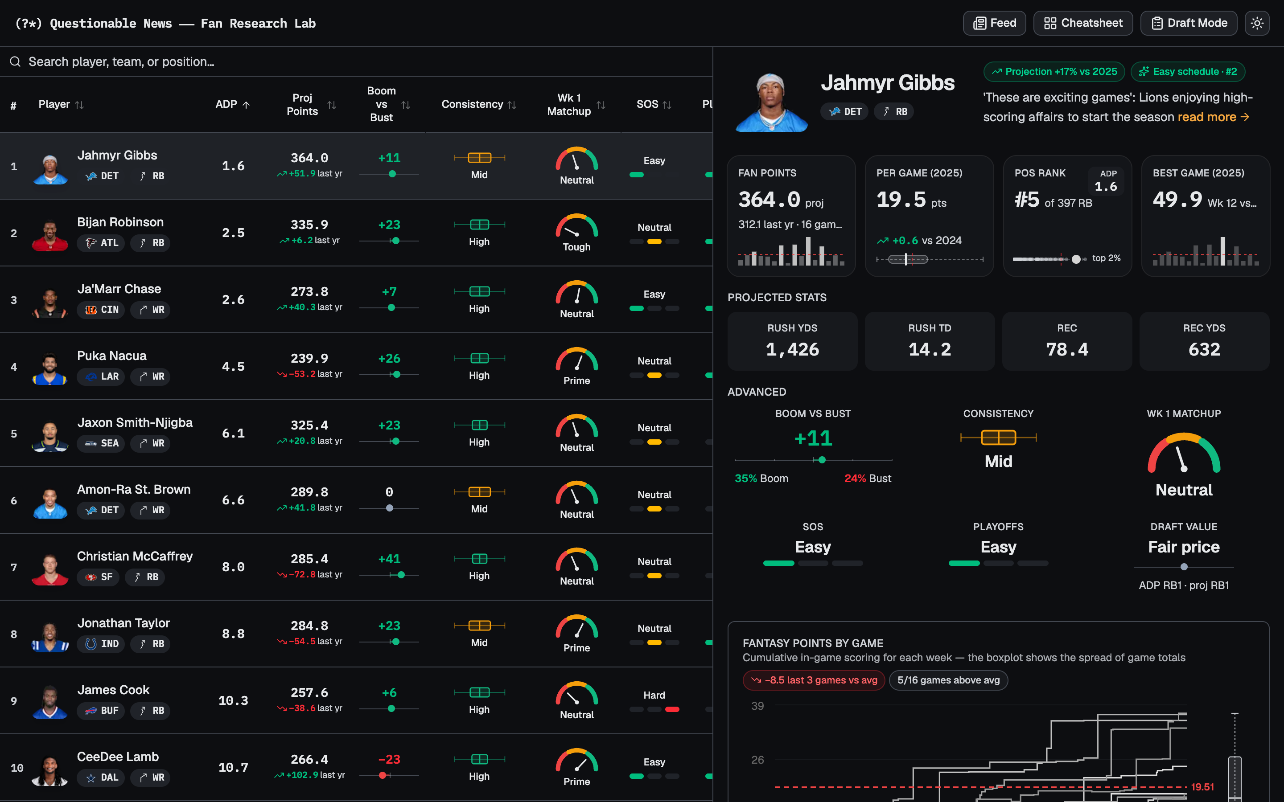
data.questionablefootball.com — the Fan Research Lab. A dense player table (ADP, projection, boom-or-bust, consistency, matchup gauge, strength of schedule) beside a detail panel with the cumulative in-game scoring chart. The package takes the light-mode look of this site's cheatsheet, the position colors, and the game-flow chart. The data comes from the obj-football-pbp project. (full page: prior-qf-full.png)
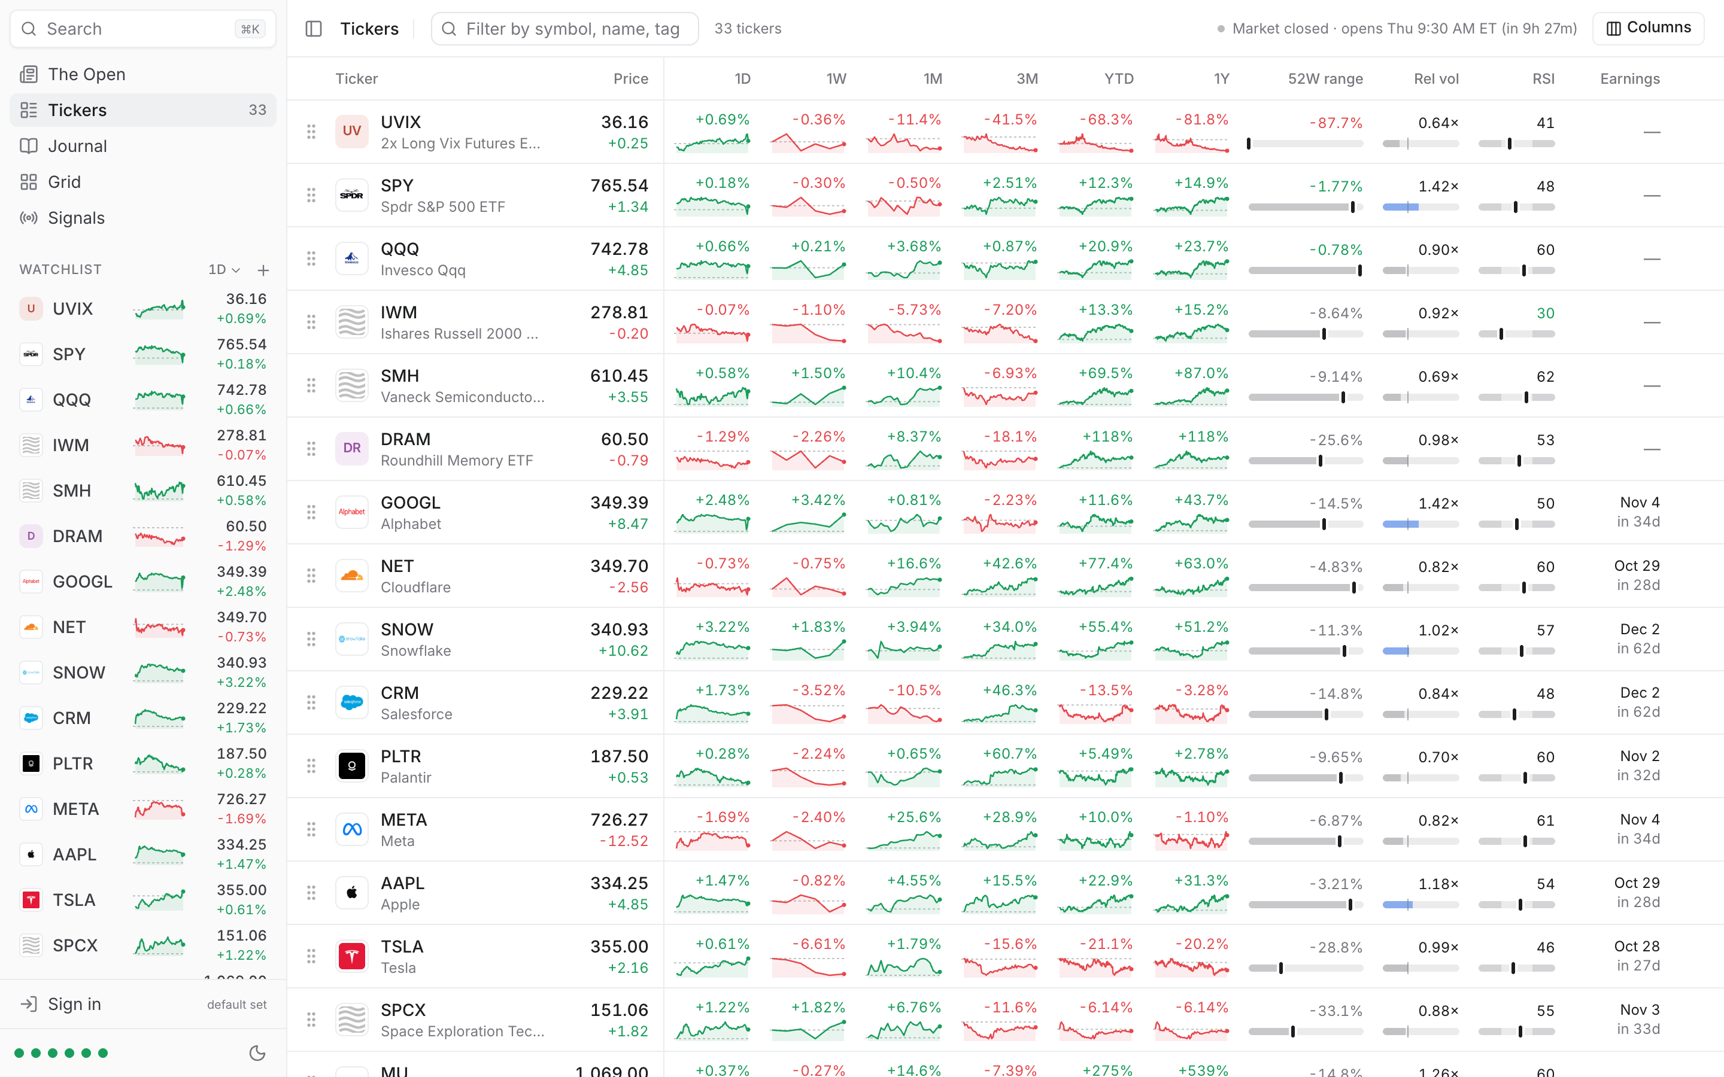
stocks.getobjective.app (Folio) — a watchlist and trading-diary app over the same 33 tickers: per-timeframe sparklines, 52-week range bars, relative volume, RSI and the next earnings date. Its SignalForge features and its cached Unusual Whales payloads became the signals-research data. (full page: prior-stocks-full.png)
In both originals the rules live in code that the reader can't see: an SQL export script in one, application TypeScript in the other. In the packages, every rule is a named Malloy field with a #(doc). That covers the half-PPR scoring, finish ranks, value over replacement, line-implied wins, Cutler RSI, base rates and signal verdicts. A person can read them, an agent can retrieve them, and a dashboard, a notebook and a page all reuse them.

03 Worked example: Questionable Football
A draft-day tool for a fantasy manager in a 12-team, half-PPR league. The pages answer two questions: "who do I take with this pick?" and "do I take this position now, or wait for my next turn?"
- 147,928 plays, 855 games, 2023–25
- 926 players on the 2026 board
- 4 · 3 · 1 · 2 pages · dashboards · notebook · findings
- ~1.8k lines of Malloy
The model is three layers. football.malloy holds the NFL itself: teams, roster, games, and plays. fantasy.malloy scores every play under half-PPR rules written as dimensions, then rolls that up into box scores, season finishes, and the 2025 and 2026 draft markets. market.malloy holds the 2026 betting lines and futures. Each page queries a small scoped source (player_app.malloy and so on) that declares only the givens that page sends.
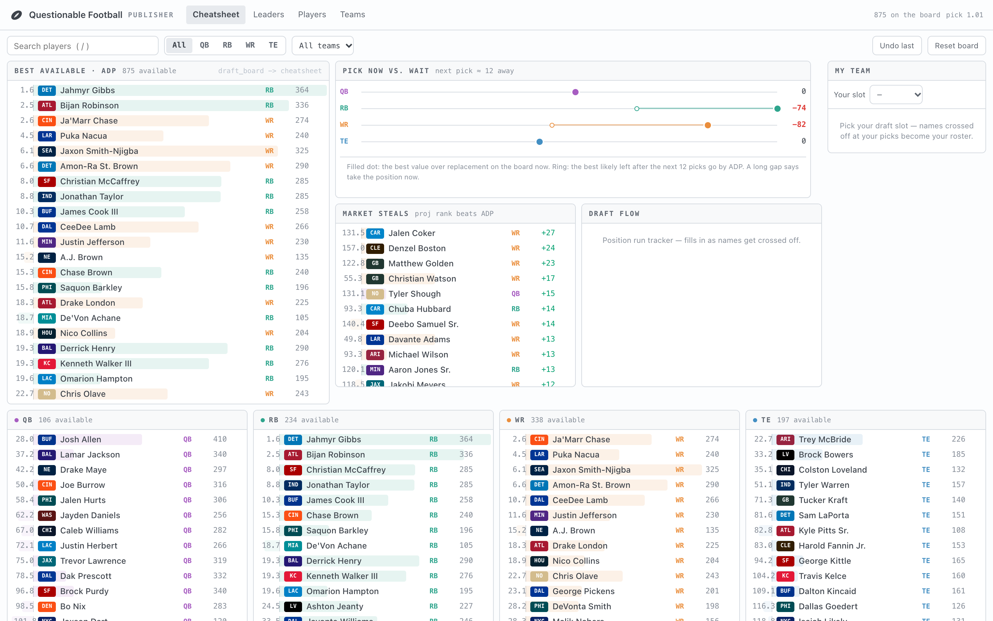
Cheatsheet — the page you keep open during the draft. The best available players by ADP lead, with value over replacement drawn as a signed bar. Pick now vs. wait compares the best value at each position now (filled dot) with the best likely to be left after the next 12 picks (ring); a long gap means take the position now. You cross players off as they're drafted, and that list is kept in the browser while the filters live in the URL. draft_board -> cheatsheet · full page
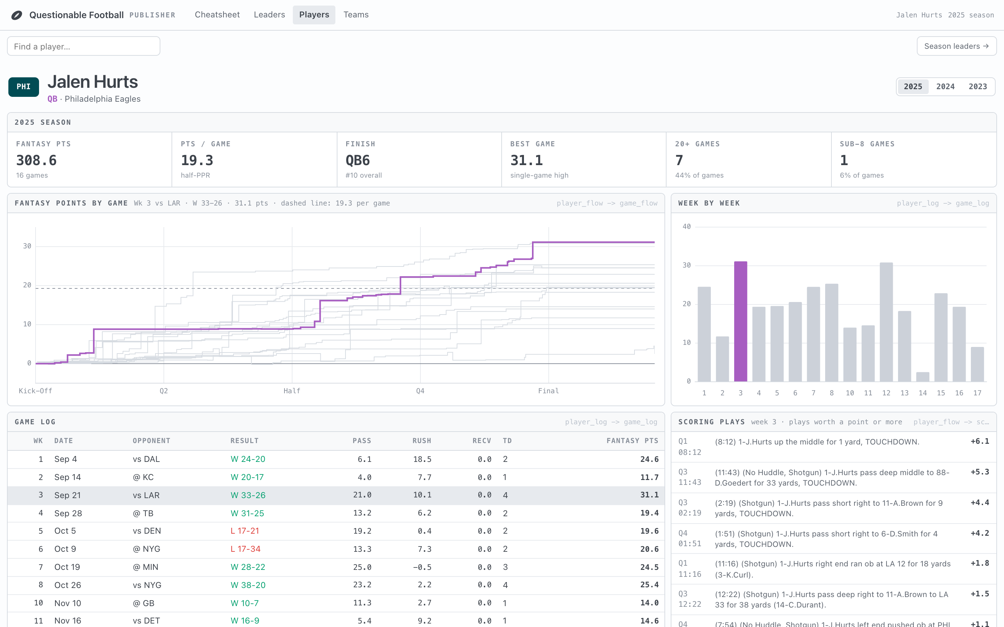
Player — the game-flow chart from the original site, rebuilt: each game's fantasy points accumulate from kickoff to the final whistle, with one game highlighted and the rest in gray. Selecting a week ties together the bars, the game log and the scoring plays, and each play shows its points next to the play-by-play text. player_flow -> game_flow · full page
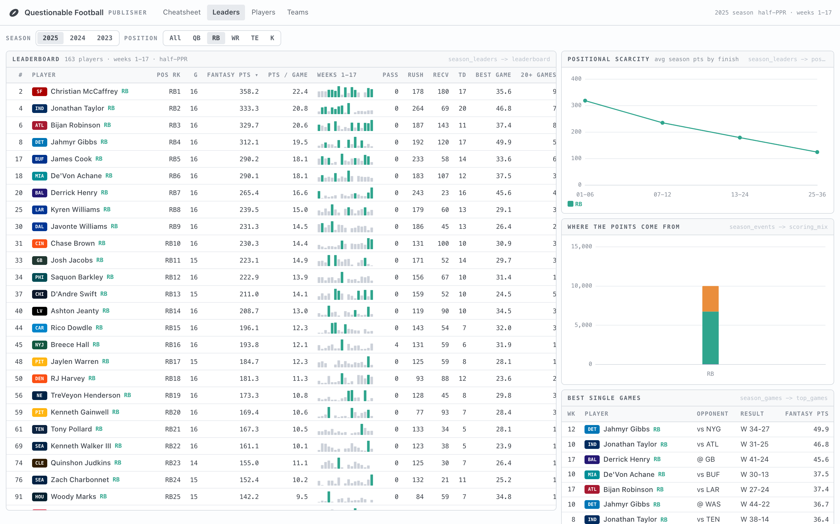
Leaders — one season's leaderboard with week-by-week sparkbars, positional scarcity, where the points come from, and the best single games. season_leaders -> leaderboard
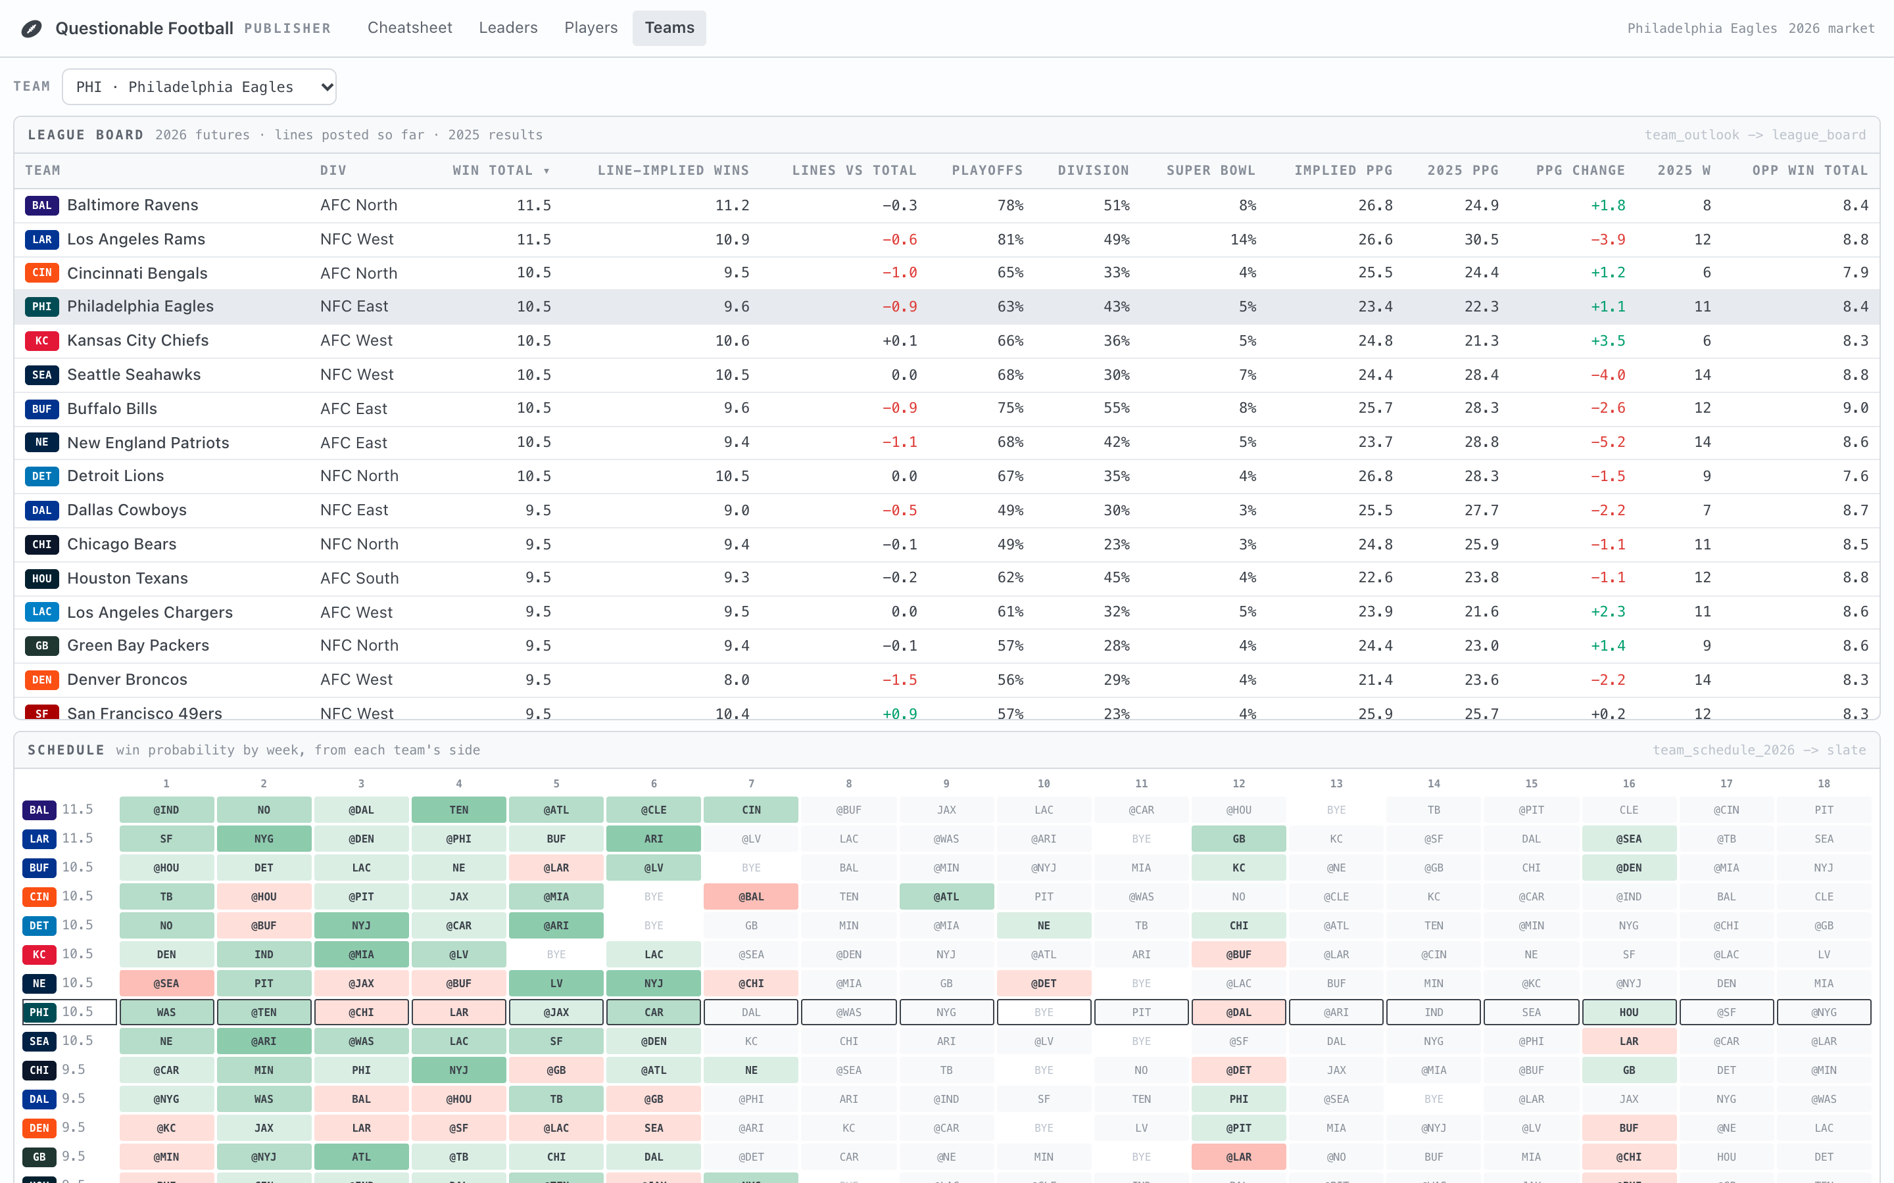
Teams — each team's win total beside the wins its lines imply, above a 32-by-18 schedule grid shaded by win probability. team_outlook -> league_board
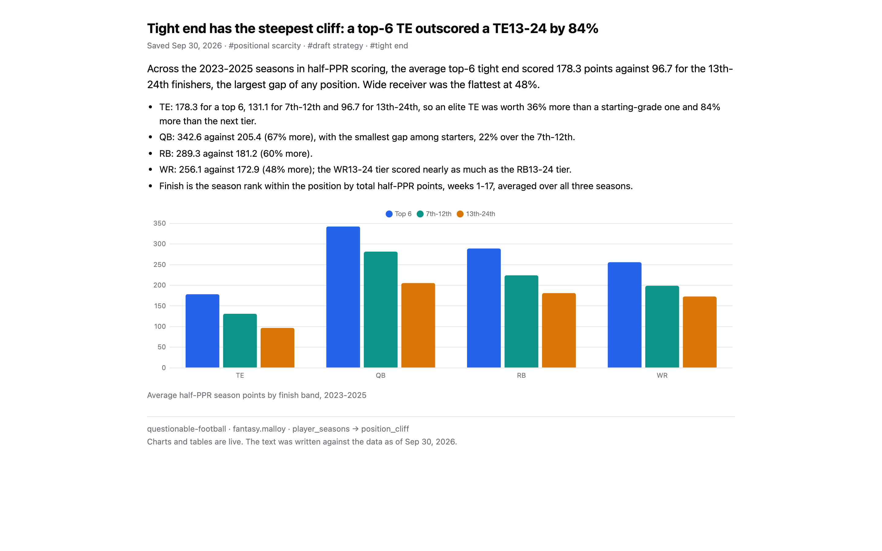
A saved finding (public/apps/the-tight-end-cliff/app.json) — the claim, the details behind it, and an evidence chart that re-runs player_seasons -> position_cliff live. The text records the data date it was written against, so a reader can tell when the chart and the prose have drifted apart.

Where the numbers changed
Porting the export script into Malloy surfaced bugs the original site still has. For example, the original export credited Keenan Allen's 2024 season to Kazmeir Allen, credited about 300 touchdowns that were later reversed or nullified, and filed the Jets in the NFC. The README lists each fix and the number it changes. This is the case for the product in one paragraph: putting the rules where someone can read them is what got them checked.

04 Worked example: Signals Research
A workbench for a discretionary trader who does their own research. The pages answer two questions: "which names need attention today?" and "has this setup actually worked before?" A signal with no track record is just a reading.
- 33 symbols, two years of daily bars
- 21 signals scored against base rates
- 3 · 2 · 1 · 3 pages · dashboards · notebook · findings
- ~1.2k lines of Malloy
market.malloy holds the raw tables. signals.malloy is the study: one row per symbol per session with every causal feature, forward returns as labels, one row per signal firing with the base rate it's judged against, and a verdict of Holds, Inverts, Noise or Thin. The page design borrows Finviz's heat map and screener, and OpenBB's terminal layout of stacked panes with a source line on every widget.
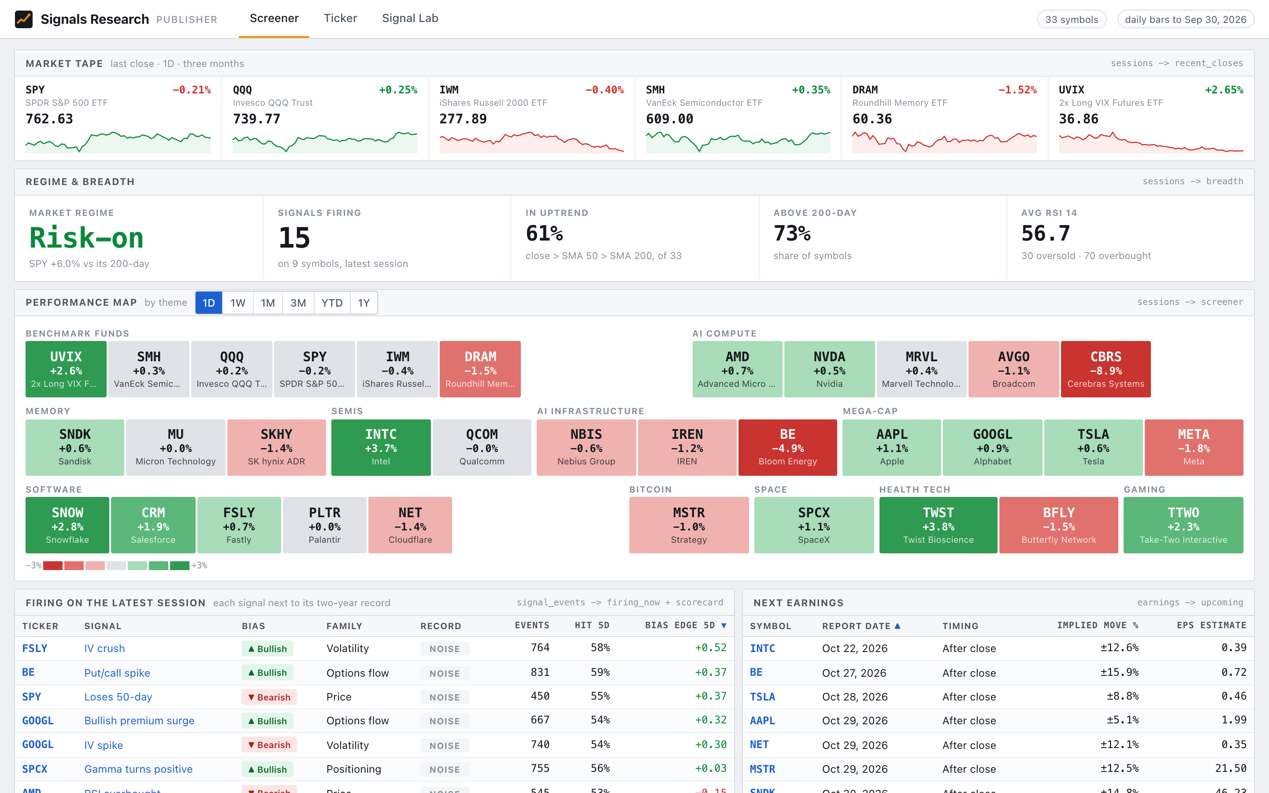
Screener — the morning glance: a tape of six benchmark funds, the market regime and breadth, a performance map grouped by theme, and every signal that fired on the latest session next to its two-year record. sessions -> screener · signal_events -> firing_now · full page
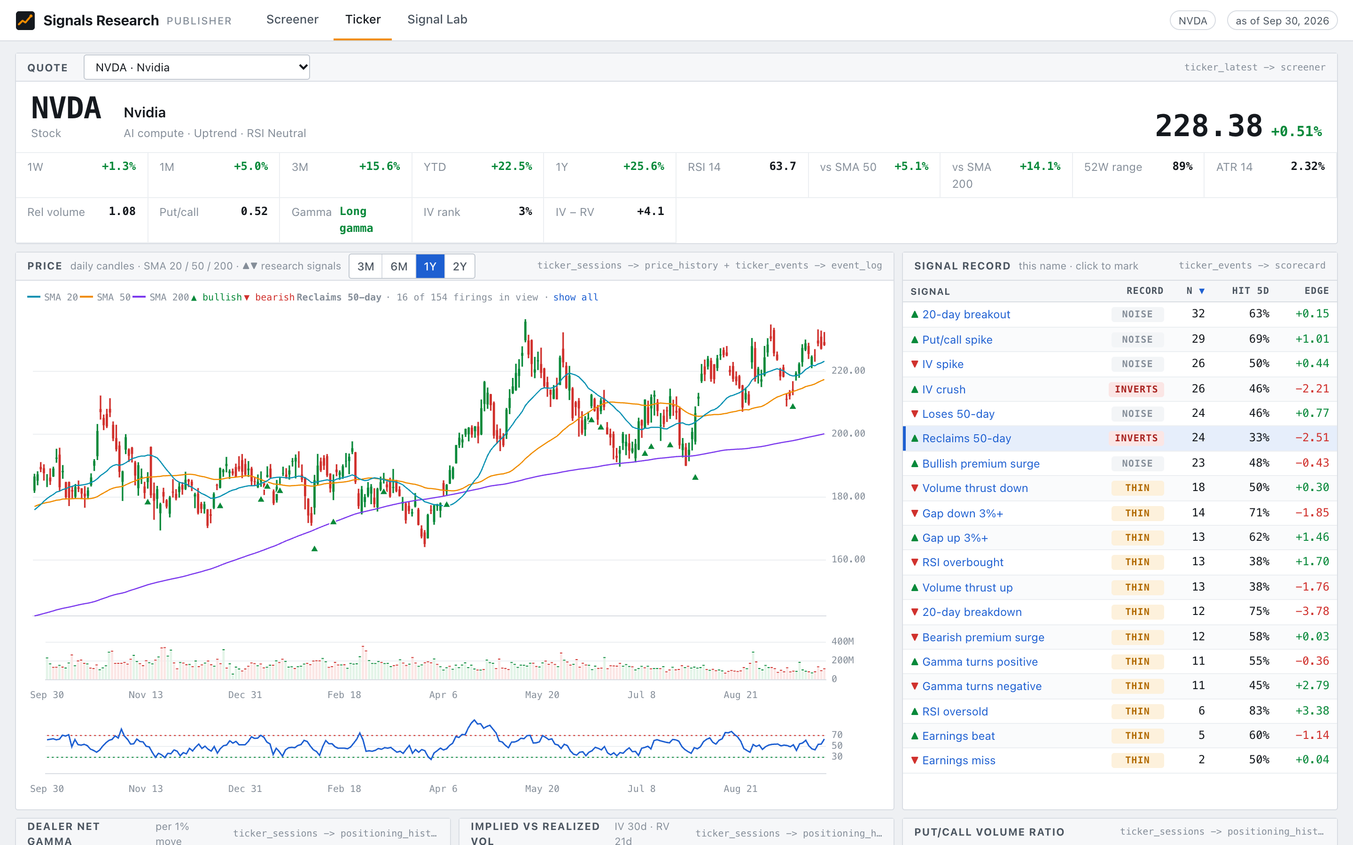
Ticker — a terminal for one symbol. Candles with SMA 20/50/200, volume and RSI, with signal firings marked on the chart. Clicking a row in the Signal record isolates that signal's firings, scored against this symbol's own history. Here Reclaims 50-day inverts on NVDA. ticker_sessions -> price_history + ticker_events -> event_log · full page
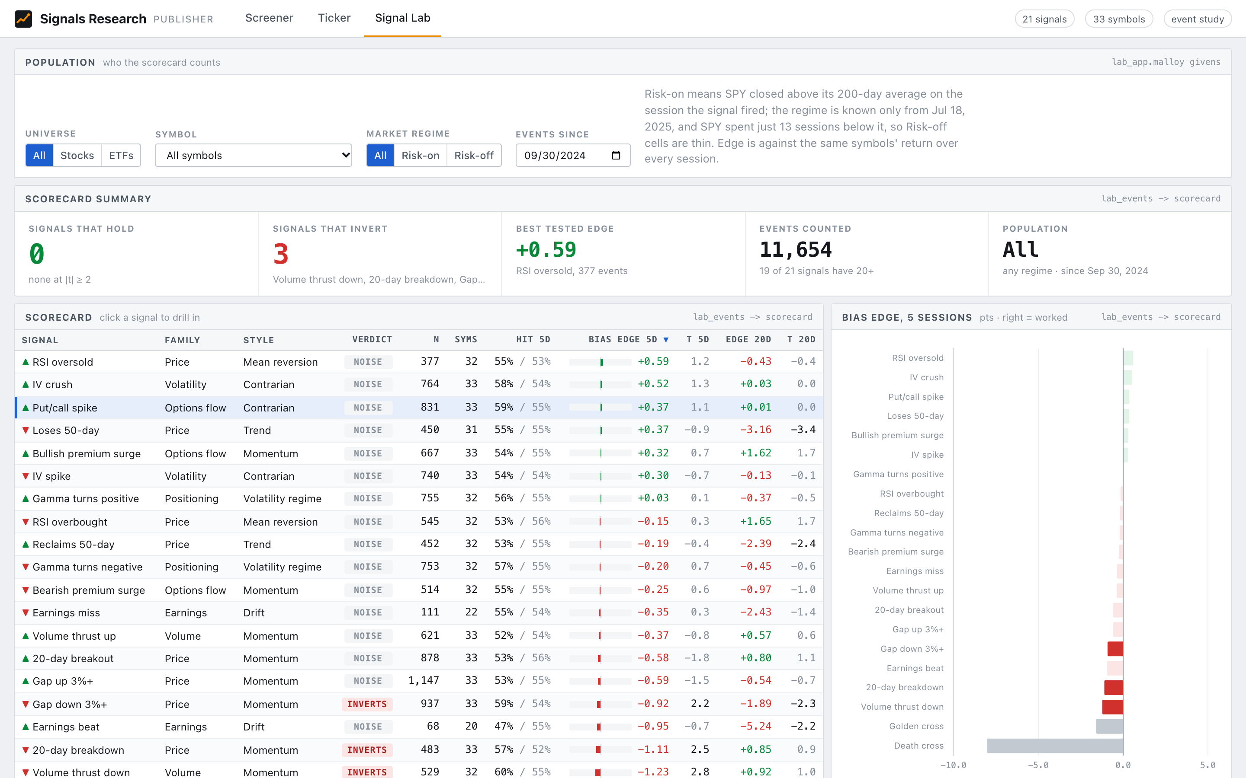
Signal Lab — set the population (universe, symbol, regime, start date), read the scorecard, and drill into one signal. The drill panel is computed over the same population, so a number in it is always a slice of the row above it. lab_events -> scorecard · full page
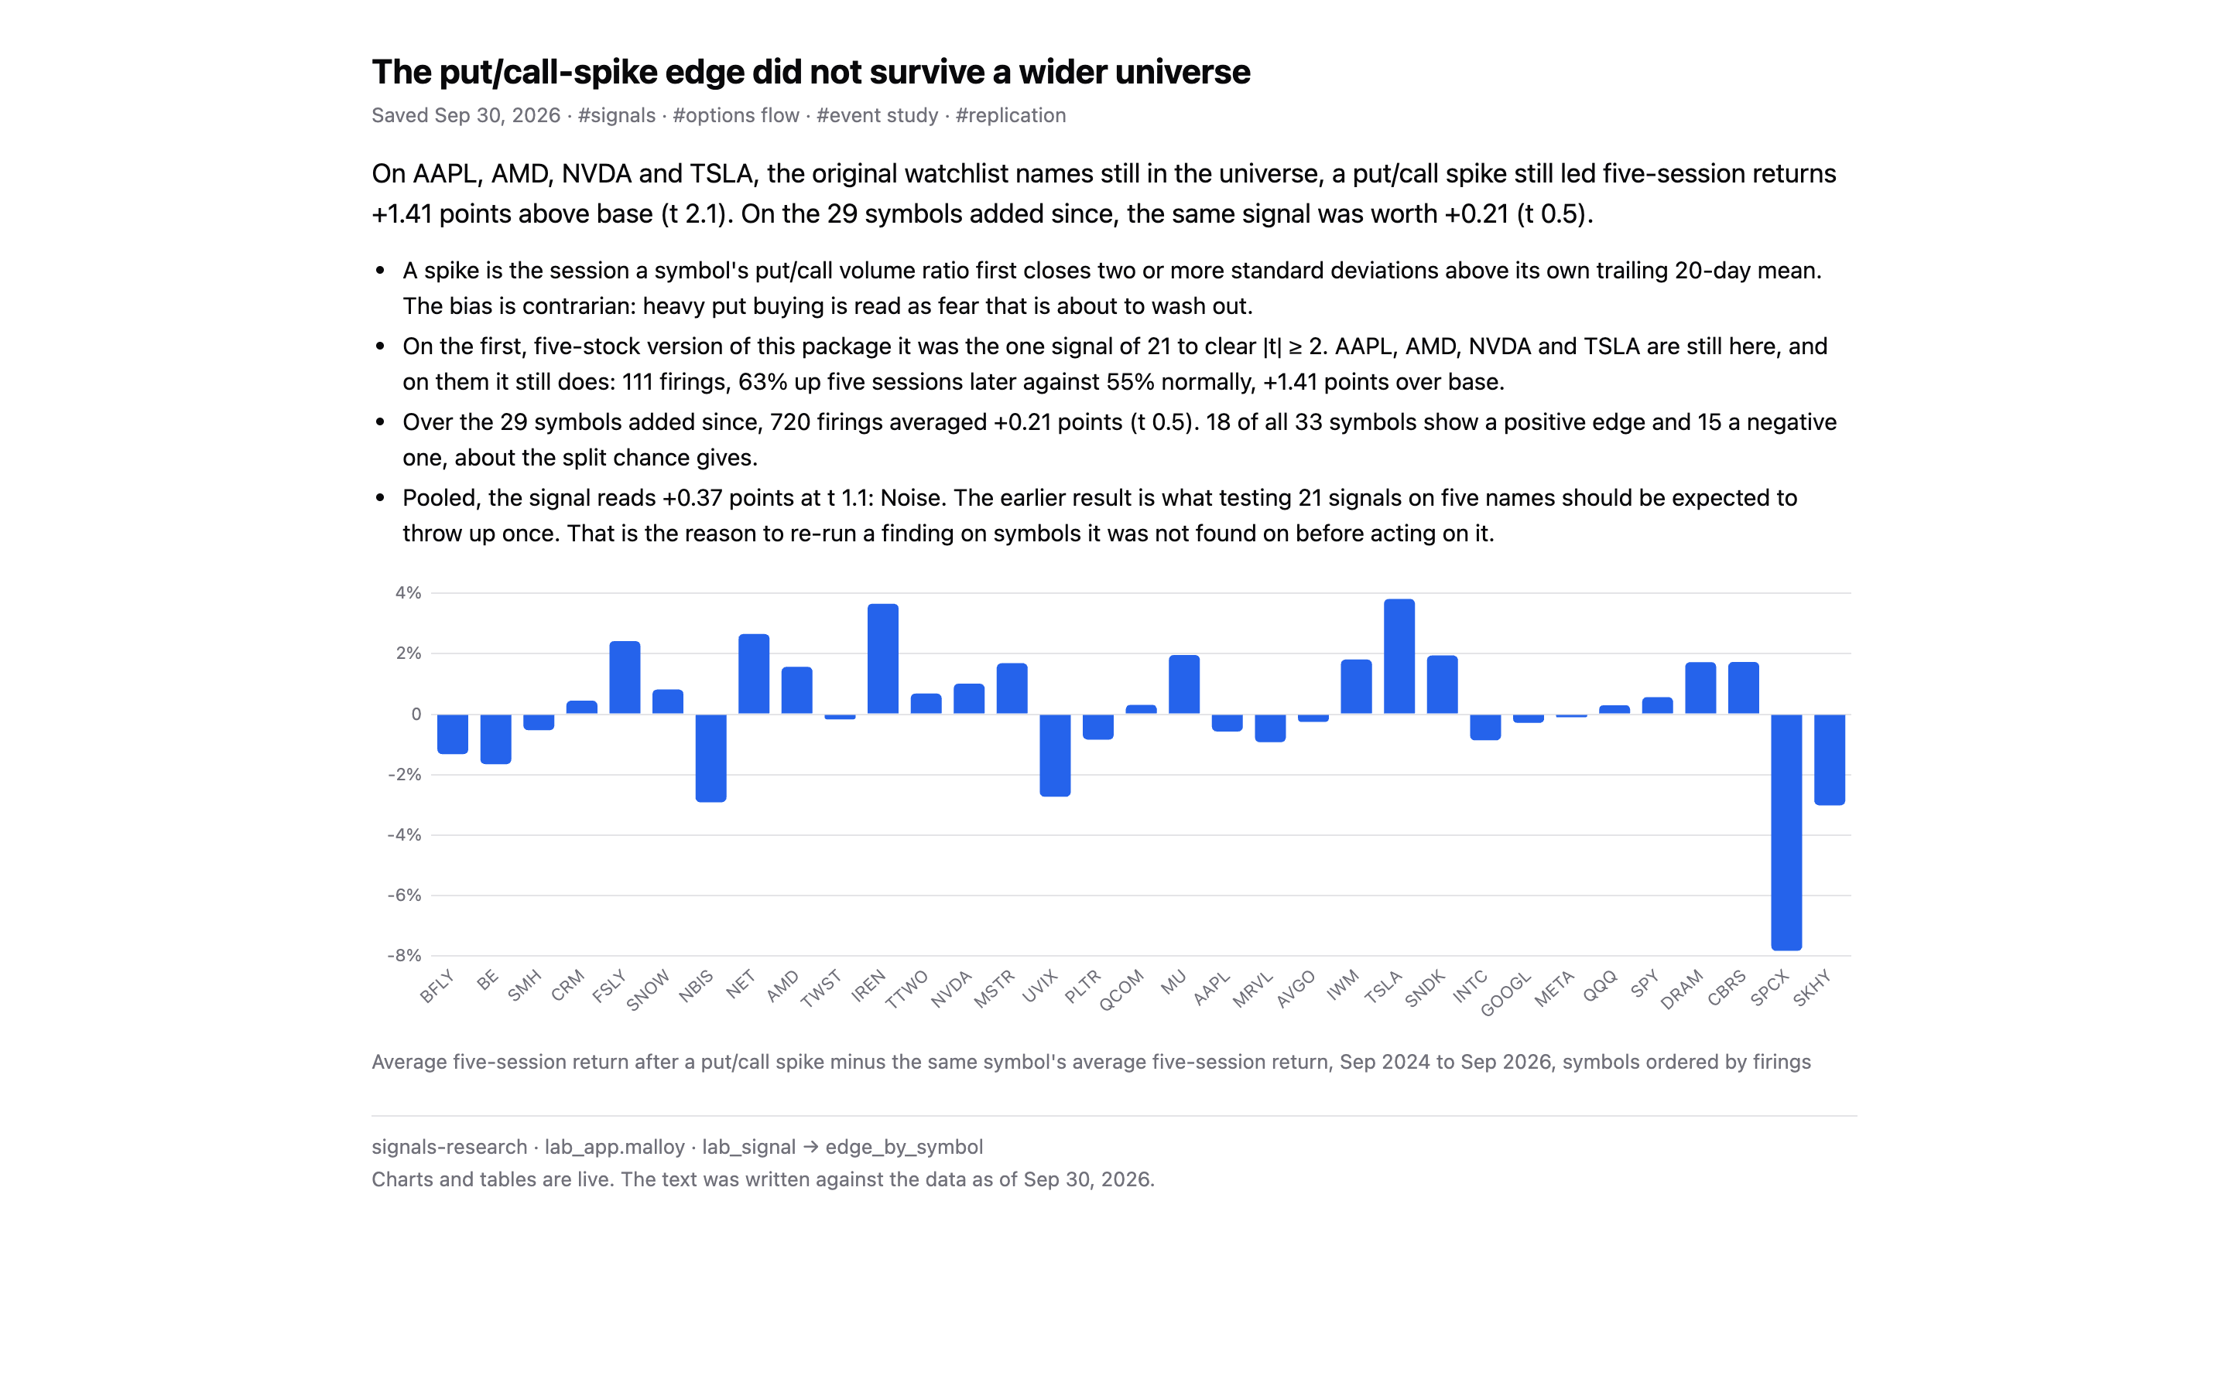
A saved finding that failed to replicate. On the original five-stock version of this package, a put/call spike was the one signal of 21 to clear |t| ≥ 2. On the 29 symbols added since, it is worth +0.21 points at t 0.5. The package keeps both findings side by side, which I think is the right default for a research tool: save the replication failure, not just the headline.

05 Teardown: what the builds taught
The patterns worth keeping, and the places where the product made me work around it.

Patterns worth making the default
- Write a design brief before drawing any tile. Who opens the page, the decision it serves, what leads, and how deep it goes. Both READMEs open with one, and the malloy-data-app-design skill now asks for it up front.
- Label every panel with source -> view. It costs almost nothing and makes any number traceable from the page back to the model.
- One scoped source file per page. *_app.malloy declares only the givens that page sends, so a page can't reach for a parameter it doesn't own.
- Keep page state in the URL. Season, position, player, symbol and signal all live in the query string, so any view can be shared as a link.
- Design tokens, read at draw time. Every color comes from style.css, and the charts read the same tokens, so no page script contains a color.
- Conformance tests. tests/conformance.test.mjs checks the rules every page shares, and bun run test:examples runs it.
- Saved findings as manifests. A finding is an app.json holding the claim, its queries, a data snapshot and the evidence chart, re-run live and written through PUT …/data-apps/{slug}, which compiles every query against the package first. That is the convention library-data-apps-plan.md builds on.

Where I worked around the product
Friction | What happened | Direction
Explorer assumes Malloy | The Fields builder is a Looker-style explore: you need to know a group-by from an aggregate, and that a chart tag goes on the view. | Question mode, §06
Givens vs. fields | Givens are declared model-wide and bound by a where:, so the explorer can't tell which filter applies to which field. | Infer the binding from the model's own text (done in Question mode)
Silent stale models | A reload that fails to compile keeps serving the old numbers. | Show the stale state in the Console, not only in /status
Shared page code | Both packages carry their own table.js, charts.js and format.js, mostly the same code. | A small optional runtime, or a scaffold template
Editor: Rank these. Add any I missed from the agent sessions, for example the npx cache, the trust gate, or the 409 on writes.

06 Proposal: Question mode
A second way to build a query in the model explorer. You answer questions instead of assembling fields, and every combination of answers draws a valid chart.

The problem
The explorer's Fields mode is a traditional explore. You pick a source, then drag dimensions into group-by, measures into aggregate, add filters, and choose a renderer. For an analyst who already thinks in Malloy, that is the right tool. For a manager, a PM, or someone who opened the Console from a link, it hands over a grammar before it hands over an answer. Most of the combinations it allows produce a table nobody wanted or a chart that can't render.
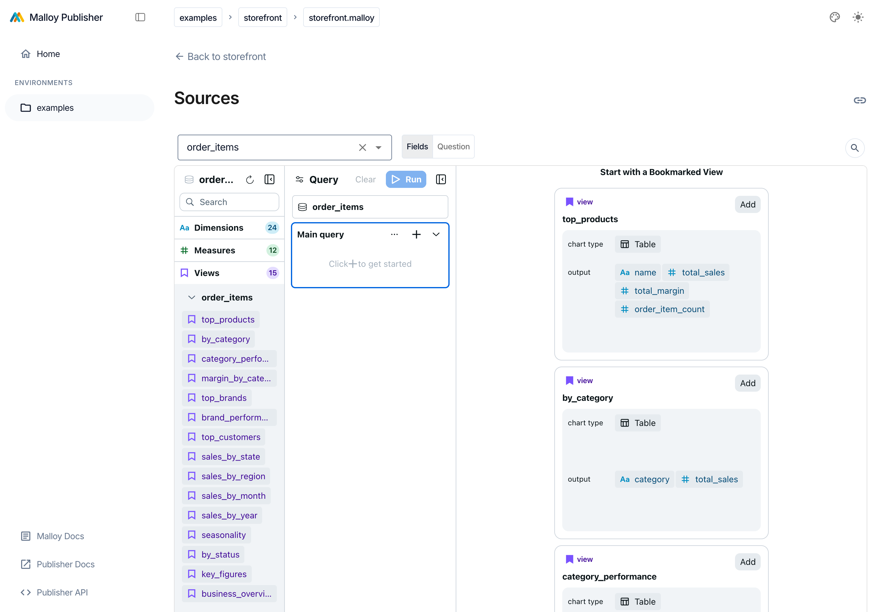
Fields mode, today. 24 dimensions, 12 measures and 15 views in a tree; a query panel of group-by, aggregate, order-by and limit; and a separate list of renderers. Everything is reachable, but nothing tells you where to start.

The design
Question mode reduces the explorer to three questions, asked in order, each unlocked by the one before:
- What would you like to measure? Pick a measure, listed by its # label and grouped by join. With nothing else answered, you get one number.
- What would you like to group by? Optional. A text dimension gives a ranked bar chart with a top-N. A date or timestamp gives a time series, with a grain picker (year through day) that appears only when it applies.
- What would you like to segment by? Optional, and only after a group-by. It splits each group into series: stacked bars, or one line per segment.
The principle is that every slot yields a valid visualization. The chart is chosen from the answers, so there is no state in which a chart can't render. Show it as defaults to Auto and names what Auto picked. You can override it, and an override the answers no longer fit says why it fell back.
Answers | Auto draws | Ordering
measure only | big value | —
+ text group-by | bar chart | by the measure, descending, top N
+ date/time group-by | line chart | by time, ascending, all rows
+ segment | stacked bar / multi-line | as above; top N groups kept whole
one text group-by, no segment | Map available (shape map) | every region, unranked
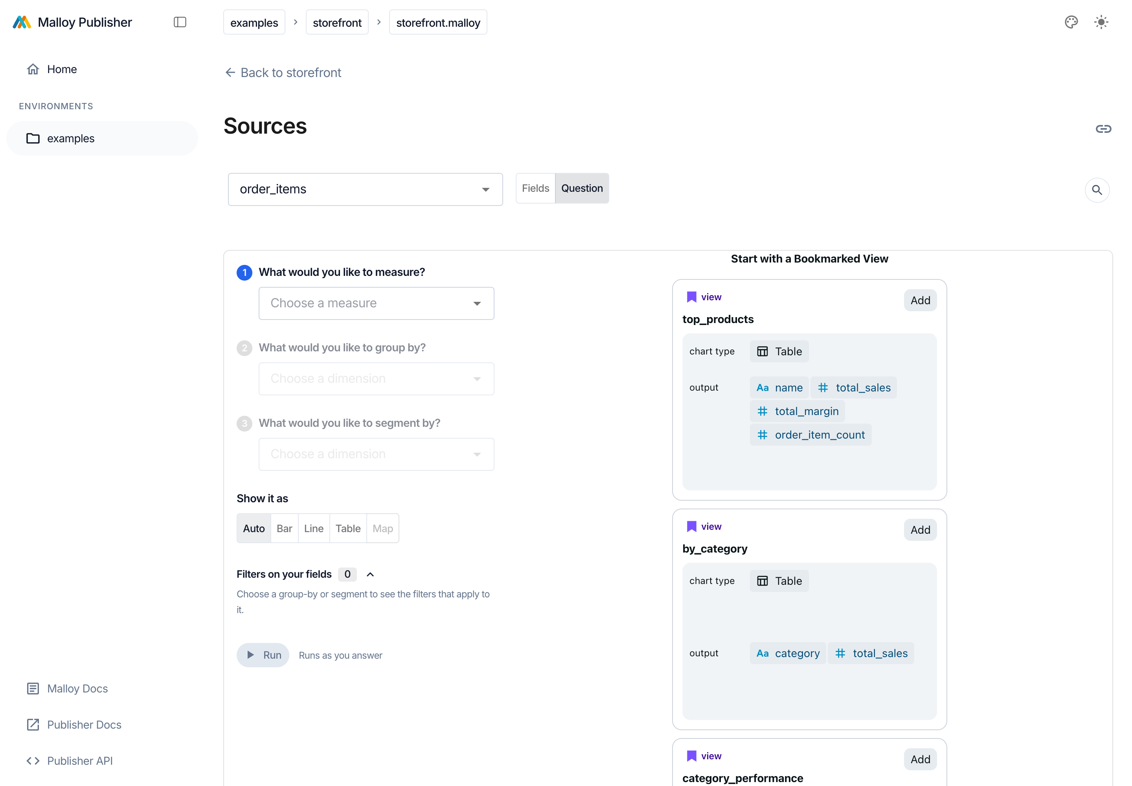
Empty state. The first question is active, and the later ones are dimmed until there is something to group.
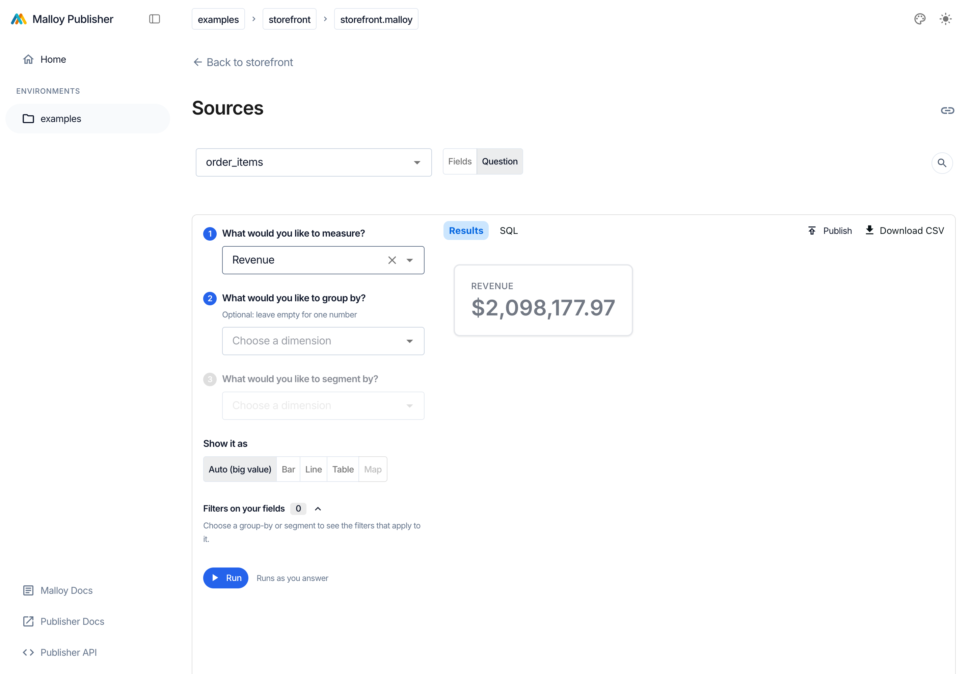
1 · Measure. "Revenue" with nothing else answered is one number. Auto names its choice: Auto (big value).
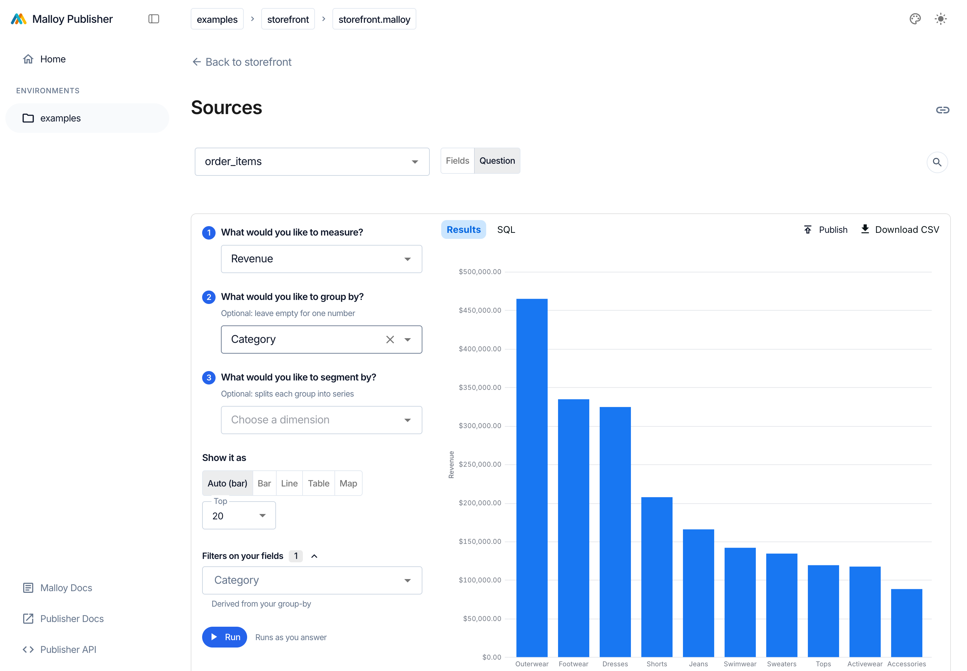
2 · Group by. "Category" gives a ranked bar chart and a Top-N control. A value filter for the chosen field appears under Filters on your fields.
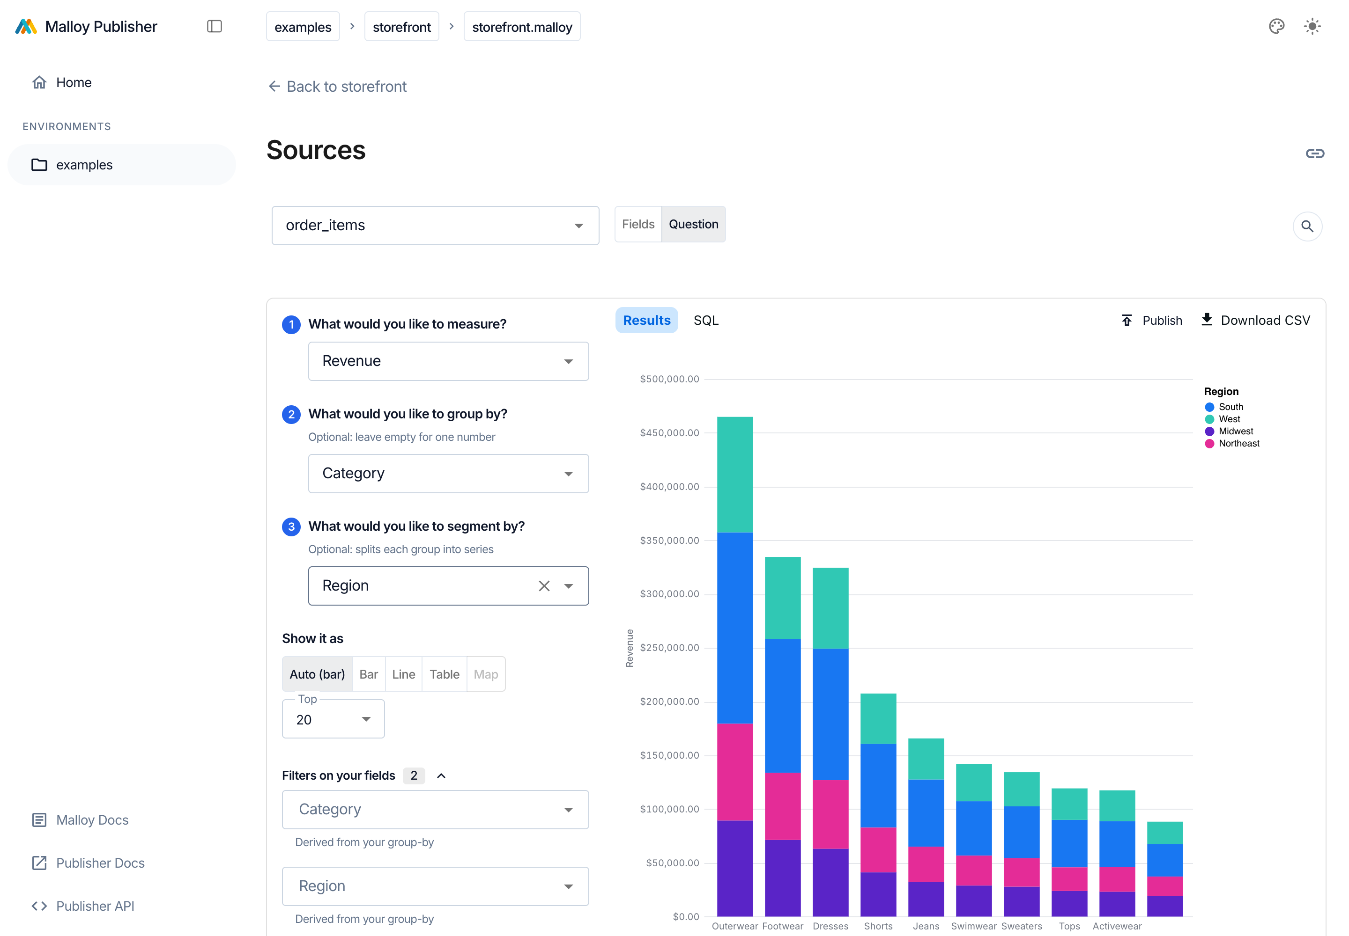
3 · Segment by. "Region" stacks the bars. Map is disabled with a tooltip, because a shape map needs one grouping and no segment.
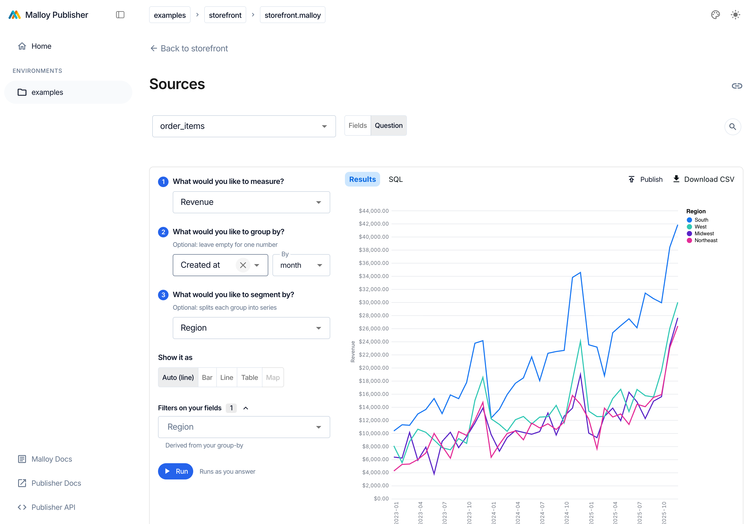
Change the group-by to a date. "Created at" switches the chart to lines, adds the By month grain picker, and hides Top-N, since a time series isn't ranked.

Filters next to the fields they filter
Publisher's givens are declared for the whole model and bind to a field through a where: that someone wrote. Fields mode shows every given in one panel, unrelated to anything you've picked. Question mode reads the bindings from the model's own text (category ~ $CATEGORY in a dashboard tile says exactly which field and operator), then falls back to the given's suggest dimension, then to a field with the same name. It then groups the filters:
- Filters on your fields: the parameters bound to your group-by or segment, plus a value filter for any chosen text field that no parameter covers.
- More filters on source: collapsed, but "every filter here applies to the result, open or not." A filter you set but can't see still counts, and the panel says so.
- Other parameters: givens that no field names. They are sent with the query and apply only if the source reads them itself.

It's still Malloy
The answers compile to plain Malloy, and the SQL tab shows what that compiles to. The stacked chart above is:
# bar_chart.stack
run: order_items -> {
group_by: category, region
aggregate: total_sales
order_by: total_sales desc
limit: 400 // top 20 categories × up to 20 segments each
}
A parameter binds as where: field ~ $GIVEN, which the query AST has no node for. That is why Question mode writes text rather than an AST, and why it only writes a binding when the given has a value or a default, so an unset parameter can't fail the whole run.

Round-trip with Fields
Switching modes keeps the query. Question mode's answers become a Fields AST, and a Fields query becomes answers, including a named view, which is expanded from the compiler's drill_expression and drill_filters annotations. A Fields query can say more than three questions can (a second measure, a nest, a having). When it does, Question mode lists what it couldn't carry instead of dropping it silently: "Not carried over from Fields: the extra measure Margin rate; the nested view by_month."
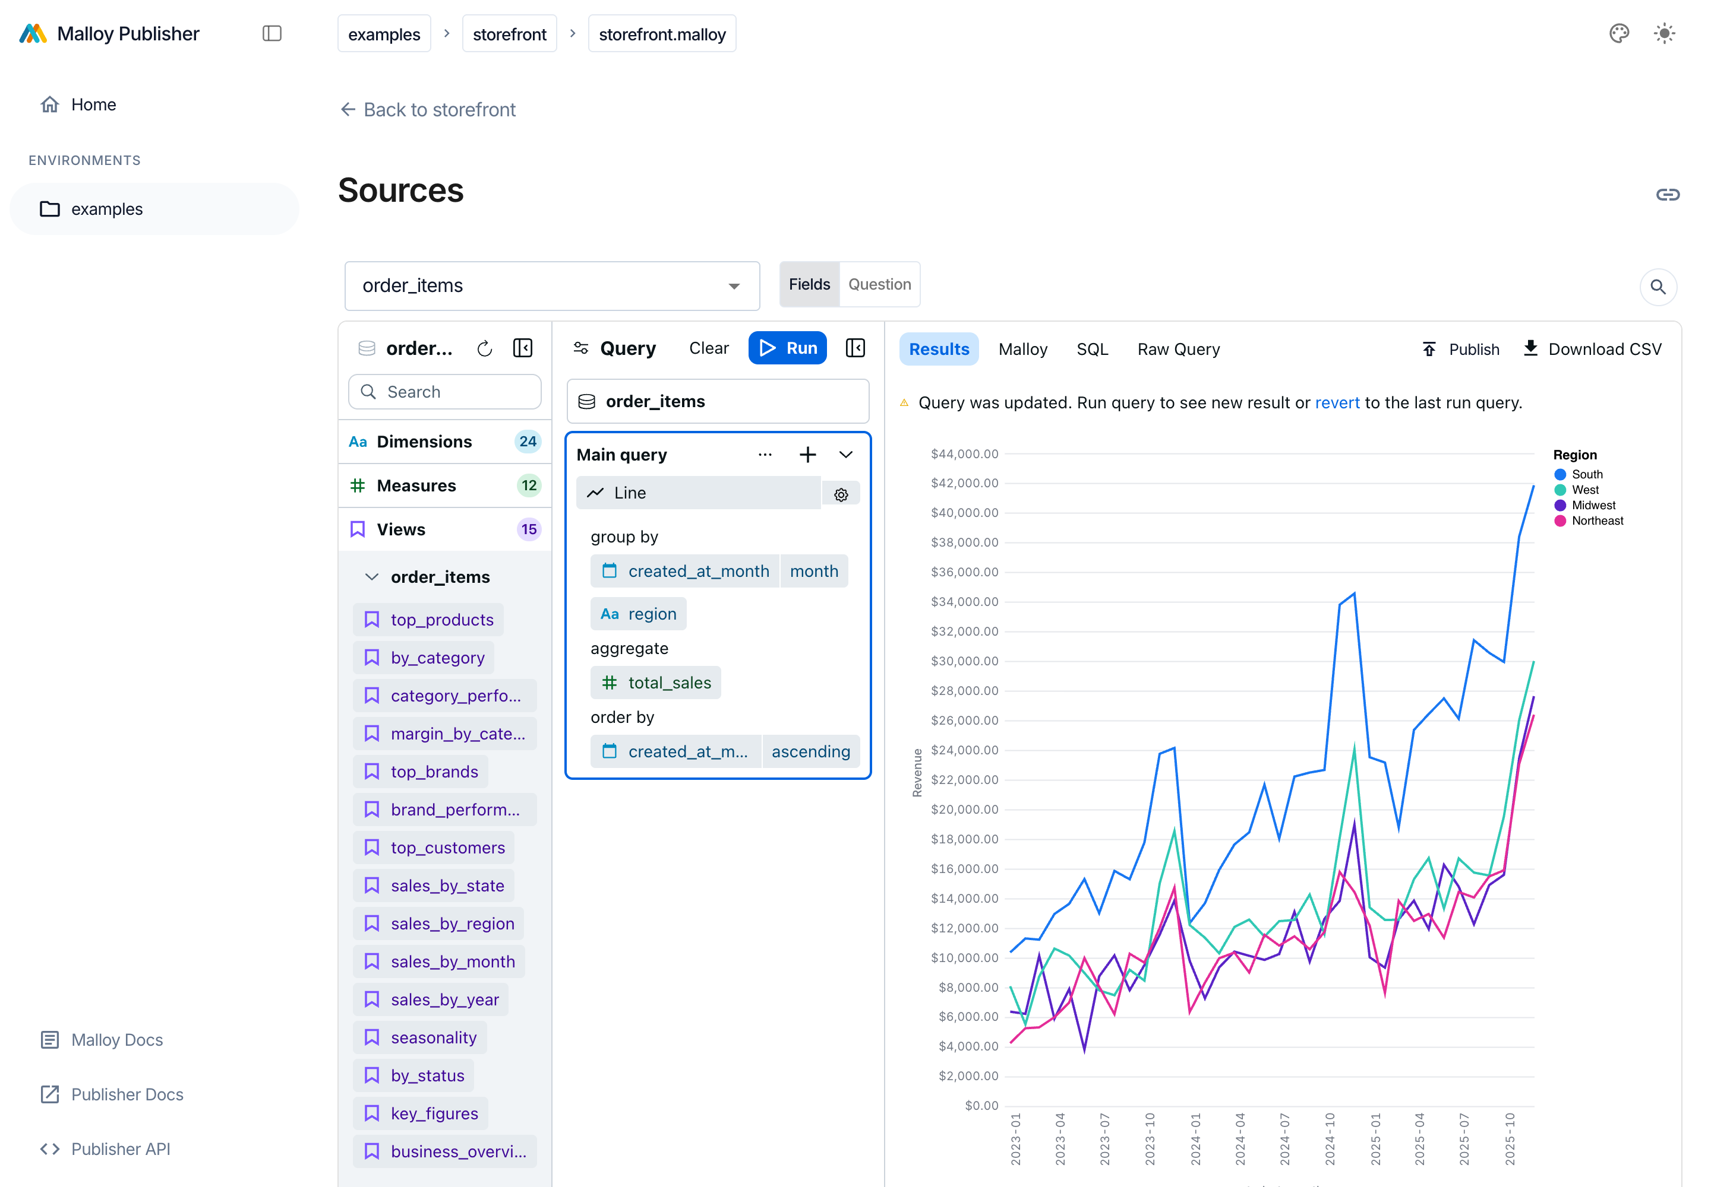
Back to Fields. The question is now an ordinary query: group-by category and region, aggregate total_sales, order descending, limit 400, rendered as a bar chart. An analyst can pick up exactly where the question left off.

Who it's for
Persona | Fields | Question
Analyst / modeler | Home. Full grammar, nests, multiple measures | A fast first draft to refine in Fields
Manager / PM | A grammar before an answer | Three plain questions, and a chart every time
Arrived from a link or a dashboard | Doesn't know which source or view to use | Starts from the measure they came to ask about
Agent-assisted | — | The three slots match how get_context retrieval is already typed (measure, dimension), a possible target for "ask in plain English, then show me the answer as slots"
Editor: Confirm the persona claims with two or three real sessions before this goes out. Add a quote if I have one.

Implementation
- packages/sdk/src/components/Model/Question/: questionQuery.ts (fields, bindings, Malloy text), interchange.ts (Fields ↔ Question), QuestionPanel.tsx (the form). About 1,700 lines, plus 24 unit tests in two spec files.
- The Fields | Question toggle in ModelExplorer.tsx, remembered in localStorage. Question mode runs 350 ms after the last answer and discards results from earlier, slower runs.
- No server change. It uses the existing query endpoint and the existing givens.

07 Status and next steps
Piece | State
examples/questionable-football, examples/signals-research | Registered in publisher.config.json; tests and lint included in bun run test:examples and lint:examples. Uncommitted.
Question mode | Working in the dev Console; unit-tested; uncommitted. Needs a Playwright check and a design pass on spacing.
Saved findings (public/apps/*) | Phases 1–4 of the Library plan are in the tree; phase 5 not started. Part 2 shows saving one from chat.

Proposed next
- Land the two packages as the "real" examples beside storefront. They exercise givens, scoped sources, dashboards, notebooks and saved findings on data people recognize.
- Ship Question mode behind the toggle, defaulting to Fields. Track which mode people pick, and whether people who start in Question mode switch to Fields.
- Open in Question mode from a dashboard tile or a saved finding: "change this question."
- Let an agent fill in the slots: a plain-English question becomes measure, group-by and segment that a person can then adjust by hand.
- Pull the shared page runtime (tables, charts, formatting, URL state) out of the two packages into something the scaffolder can offer.
Editor: Decide whether this ends as a proposal (asks and owners) or as an update (what shipped). Right now it's both.

Reproducing the screenshots
Run bun run start and bun run start:dev:react, then node docs/unboxing/capture.mjs for the apps and prior art, and node docs/unboxing/capture-question.mjs for the Question walkthrough. Both scripts write to docs/unboxing/img/.

Up next: Part 2 of 2 → — The destination: a front door for Publisher
Where the packages above end up: a Library that starts full, a Publish button in the Console, AI-drafted insights, chat answers that save back into their package, and a workspace that can look like its owner.
Publisher teardown · Part 1 of 2 · Noah · draft, Sep 30, 2026

